Contents
1. Why @BeforeAll @AfterAll annotated method should be static any internal reason for it? 2
2. What is the main difference between @Mock and @InjectMocks? 2
3. How can we mock void methods in Mockito? 2
4. What is difference between the @Mock and @Spy annotation? 2
5. What is mean by TDD and BDD? 3

Why @BeforeAll @AfterAll annotated method should be static any internal reason for it?
In JUnit 5, the @BeforeAll and @AfterAll annotations are used to mark methods that should run once before and after all the test methods in a test class, respectively. These methods are required to be static for several reasons:
- Lifecycle Management: Since @BeforeAll and @AfterAll methods are meant to be executed once for the entire class, they are tied to the class lifecycle rather than an instance of the class. Making them static ensures that they belong to the class itself and not to any particular instance.
- No Test Instance: At the time these methods are executed, no instances of the test class have been created yet. JUnit runs these methods before any test instances are created, so if they were not static, there would be no way to invoke them without an instance, which wouldn't exist at that point.
- Performance: By using static methods, there’s no need to create an object of the test class just to run setup or teardown logic, which can improve performance slightly, especially in large test suites.

What is the main difference between @Mock and @InjectMocks?
"@Mock" is used to create a mock object for a specific class, while "@InjectMocks" is used to inject those mock objects into the class you are testing.

How can we mock void methods in Mockito?
Void methods can be used with Mockito’s doNothing(), doThrow(), and doAnswer() methods, making mocking and verifying intuitive, also we can use ArgumentCaptor to check for void method
Resources: https://www.baeldung.com/mockito-void-methods

What is difference between the @Mock and @Spy annotation?
Mock: Mock object replace mocked class entirely, returning recorded or default values. You can create mock out of “thin air”. This is what is mostly used during unit testing.
Spy: The @Spy annotation is used to create a real object and spy on that real object. A spy helps to call all the normal methods of the object while still tracking every interaction, just as we would with a mock.
Resources: https://howtodoinjava.com/mockito/mockito-annotations/

What is mean by TDD and BDD?
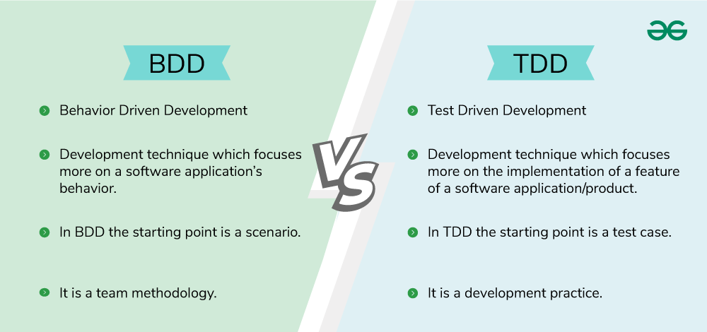
Behavior Driven Development | Test Driven Development
Behavior Driven Development is a development technique which focuses more on a software application’s behavior. | Test Driven Development is a development technique which focuses more on the implementation of a feature of a software application/product.
In BDD the participants are Developers, Customer, QAs. | In TDD the participants are developers.
Mainly it creates an executable specification that fails because the respective feature doesn’t exist, then writing the simplest code that can make the specification pass and as a result we get the required behavior implemented in the system. | Mainly it refers to write a test case that fails because the specified functionality doesn’t exist and after that update the code that can make the test case pass and as a result we get the feature implemented in the system.
Its main focus is on system requirements. | Its main focus is on unit test.
In BDD the starting point is a scenario. | In TDD the starting point is a test case.
It is a team methodology. | It is a development practice.
Here language used to write behavior/scenarios is simple English language. | Here language is used is similar to the one used for feature development like programming language.
In BDD collaboration is required between all the stakeholders. | In TDD collaboration is required only between the developers.
It is a good approach for project development which are driven by user actions. | It is a good approach for projects which involve API and third-party tools.
Some of the tools used are Cucumber, Dave, JBehave, Spec Flow, Concordian, BeanSpec etc. | Some of the tools used are JBehave, JDave, Cucumber, Spec Flow, BeanSpec, FitNesse etc.

Resources: https://www.geeksforgeeks.org/difference-between-bdd-vs-tdd-in-software-engineering/

